Quiz Game (Human Body)

**Name** = Ali Abdullah

**Email** = [rznltfm@gmail.com](mailto:rznltfm@gmail.com)

This is the project which asks different question from the users. The computer will give 30 questions and will ask from the user the answer of the question as an input. When the user will enter the answer, the computer will display you are ‘CORRECT’! or ‘WRONG’. As the user will enter the correct answer the computer will increase the score and will display +1 but when it will be the wrong answer so the computer will display +0. There are also levels: easy, hard and medium.

This is the screenshot when the computer will display the level, question and will take the answer from the user as an input: -

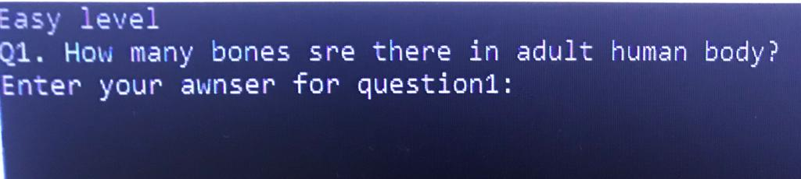

this is the screenshot when the user will enter the correct answer, the computer will display ‘CORRECT’ and Score+1. Then the computer will display the next question: -

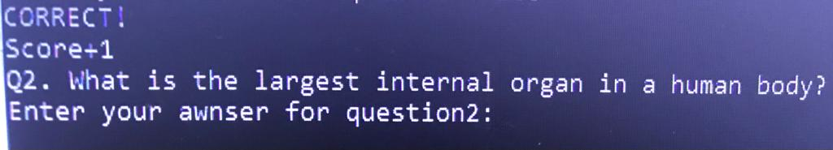

This is the screenshot when the user enters the wrong answer that’s why the computer displayed ‘WRONG’ and Score +0. Then the computer will display the next question: -

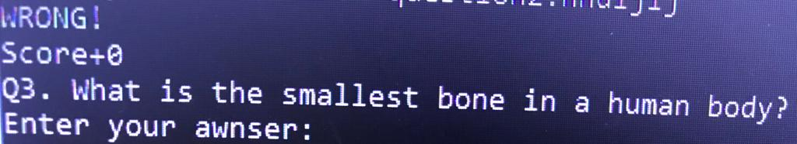

This is my github repository link for the Quiz Game: **https://github.com/Greenboy123456/BanoQabil-2.0-Python-Course.git**